|  |  |
| --- | --- |
|  | PROJECT DESIGN PHASE – I SOLUTION ARCHITECTURE |
| TEAM ID | PNT2022TMID24187 |
| PROJECT NAME | Smart Farmer-IOT Enabled Smart Farming Application |

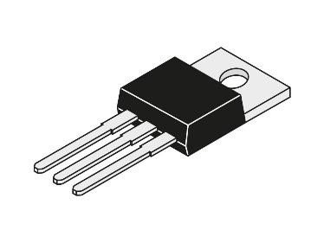

Temperature Sensor

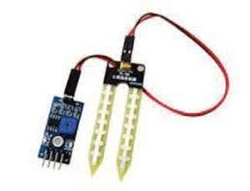

Soil Moisture Sensor

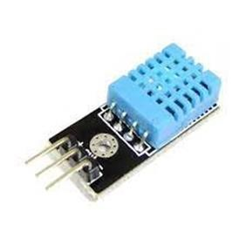

Humidity

Sensor



Monitoring w

ater level

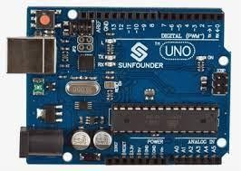

Arduino UNO



Databas

e



Cloud Server



Android application



Smart Farmer

Power Supply